Operation Improvement at Warehouse

***Current Plan（現行案）***

**Everyone distribute each meal at random. This is inefficient because that system makes us confuse and losing times.**

***Alternative Plan（代替案）***

**Everyone distribute meals to each area at the same time. For example, if the meals come to warehouse, please distribute to SMBC first. After everyone distribute meals to SMBC, then distribute to Liverpool please.**

**①SMBC**

**②Liverpool**

**③Bank**

**④Insurance**

**⑤London Wall**

**⑥St.Paul**

**⑦MUFG**

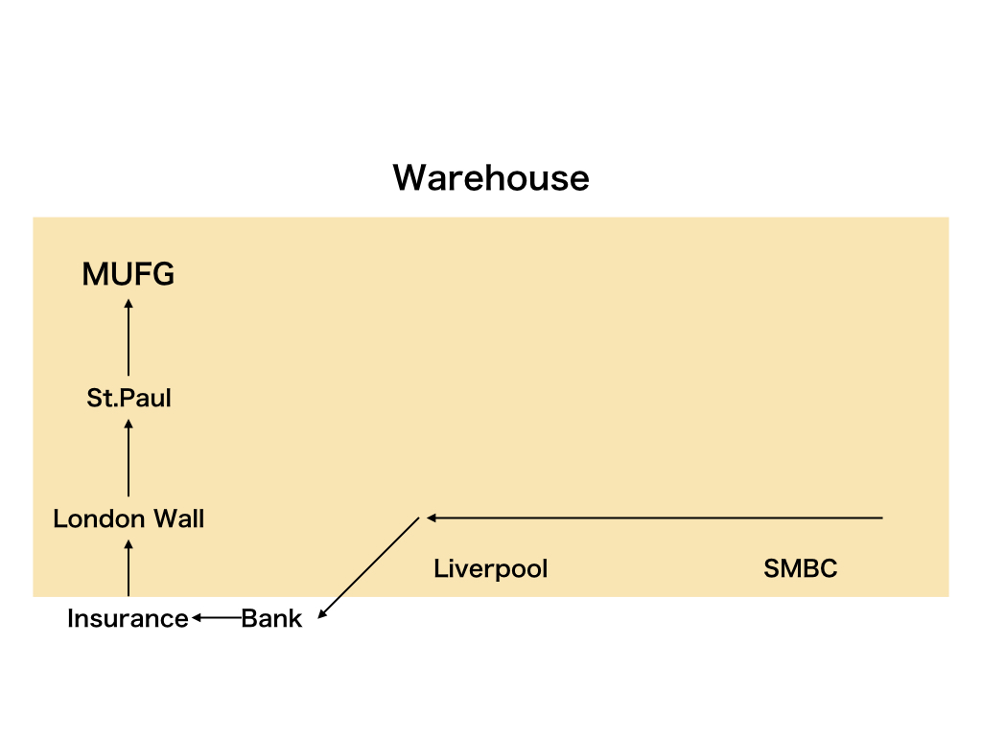

**Please prepare meals in this order. Make sure not to distribute meals randomly to each area. Plus, please make sure if it is correctly distributed all meals to one area before move to prepare for next area.**